Car Rental System

**Table of contents:**

* The implemented features
* ERD model
* Description of logic of each page

**First: The implemented features:**

• The system should be able to register a new car (model, year, plate id, etc.) and update car status (active, out of service, rented, etc.),

• Customers will be able to reserve their cars from anywhere in the world via this system (Multiple offices).

• Customers provide information to this application by filling in their personal information to create an account and then he or she can reserve a car.

• The proposed system effectively and efficiently automates manual procedures for car reservation (reserve, pick up, return, payment, etc.).

• Customers are aided by your system to search the available cars by any of the car specs according to their needs.

• System should be able to make advanced search which is searching by any of the car information, customer information or reservation day and get all information about the car, customer and reservation.

• The system should provide the basic necessary reports: o All reservations within a specified period including all car and customer information. o All reservations of any car within a specified period including all car information. o The status of all cars on a specific day. o All reservations of specific customer including customer information, car model and plate id. o Daily payments within specific period.

• Populate the system with enough data for testing all components and complete system demo.

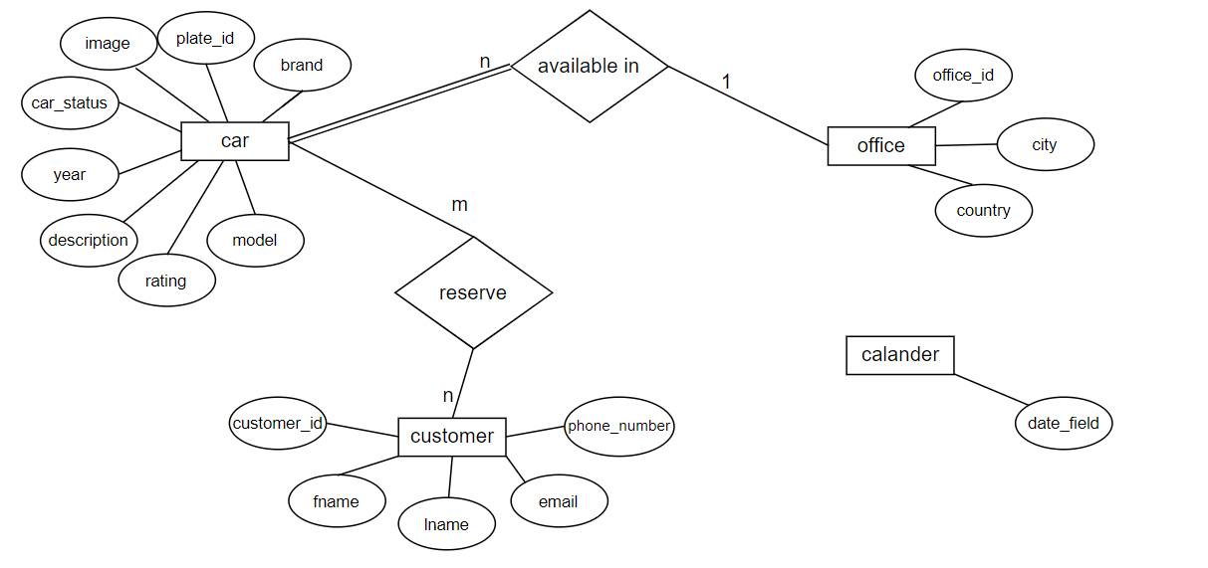**Second: ERD model:**

**Third: Description of logic of each page:**

welcome.php

which is the first page when you open a website telling the customers what the website is about and prompts the customer to take an action either to register or to login if he/she already has an account.

loginn.php

login page where the user enters his email and password whether he is an admin or a customer; if the user is an admin with specific email and password will move him to admin.php page to make modifications.

If the user is a customer who has an account then will move him to view.php page.

registration.php

Registration page where the user enters his first name, last name, email, phone number and chooses a password to sign up and make an account and also will move him to view.php page.

**For the admin :**

The first page opens after logging in is admin.php which contain all the following options: add car, update car, search with car information, search with customer information, search with reservation information, daily reports, log out and this page is the main page for the admin as it is considered the entry.

add_car.php : for adding new car

update_car.php: for modifying any attribute of the car

search_car.php: for searching for any attribute of the car

search_customer.php: for searching for any attribute of the customer

search_reservation.php: for searching for a reservation date

reports.php:

Choosing any one from the following:

1. For getting reports of reservation by entering start date and end date you want and entering plate_id if you want specific car.
2. For getting reports of all car status by entering a day date.
3. For getting reports of reservation that a customer made by entering first name and last name.
4. For getting reports of daily payment by entering start date and end date you want.

welcome.php: log out will move to welcome.php page